1. ER-Modell

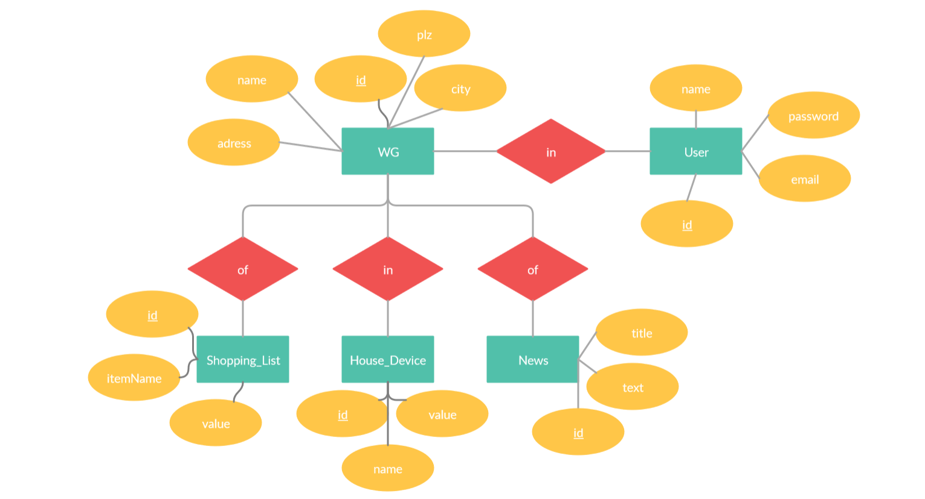

n

1

n

n

n

1

<

<

2. Abbildung der Tabellen

**WG** (id, name, adress, city, plz)

**User** (id, name, email, password)

**Shopping_List** (id, itemName, value)

**House_Device** (id, name, value)

**News** (id, title, text)

5. Integritätsbedingungen

→WG

|  |  |  |  |  |
| --- | --- | --- | --- | --- |
| **Attribut** | **Kurzbeschreibung** | **Datentyp** | **Wertebereich** | **NULL zulässig** |
| id | Primärschlüssel | Int(10) | 1-10 Stellen | No |
| Name | Primärschlüssel | String(50) | 1-50 Zeichen | No |
| adress | Primärschlüssel | String(50) | 1-50 Zeichen | No |
| city | Primärschlüssel | String(50) | 1-50 Zeichen | No |
| Plz | Primärschlüssel | Int(5) | 1-5 Stellen | No |

→User

|  |  |  |  |  |
| --- | --- | --- | --- | --- |
| **Attribut** | **Kurzbeschreibung** | **Datentyp** | **Wertebereich** | **NULL zulässig** |
| Id | Primärschlüssel | Int(10) | 1-10 Stellen | No |
| Name | Primärschlüssel | String(50) | 1-50 Zeichen | No |
| email | Primärschlüssel | String(50) | 1-50 Zeichen | No |
| password | Primärschlüssel | String(10) | 1-10 Zeichen | No |

→Shopping_List

|  |  |  |  |  |
| --- | --- | --- | --- | --- |
| **Attribut** | **Kurzbeschreibung** | **Datentyp** | **Wertebereich** | **NULL zulässig** |
| Id | Primärschlüssel | Int(10) | 1-10 Stellen | No |
| itemName | Primärschlüssel | String(50) | 1-50 Zeichen | No |
| value | Primärschlüssel | Int(1) | eine Stelle | yes |

→House_Device

|  |  |  |  |  |
| --- | --- | --- | --- | --- |
| **Attribut** | **Kurzbeschreibung** | **Datentyp** | **Wertebereich** | **NULL zulässig** |
| Id | Primärschlüssel | Int(10) | 1-10 Stellen | No |
| Name | Primärschlüssel | String(50) | 1-50 Zeichen | No |
| value | Primärschlüssel | Int(1) | Eine Stelle | yes |

→News

|  |  |  |  |  |
| --- | --- | --- | --- | --- |
| **Attribut** | **Kurzbeschreibung** | **Datentyp** | **Wertebereich** | **NULL zulässig** |
| Id | Primärschlüssel | Int(10) | 1-10 Stellen | No |
| Text | Primärschlüssel | String(50) | 1-50 Zeichen | No |
| title | Primärschlüssel | String(50) | 1-50 Zeichen | No |